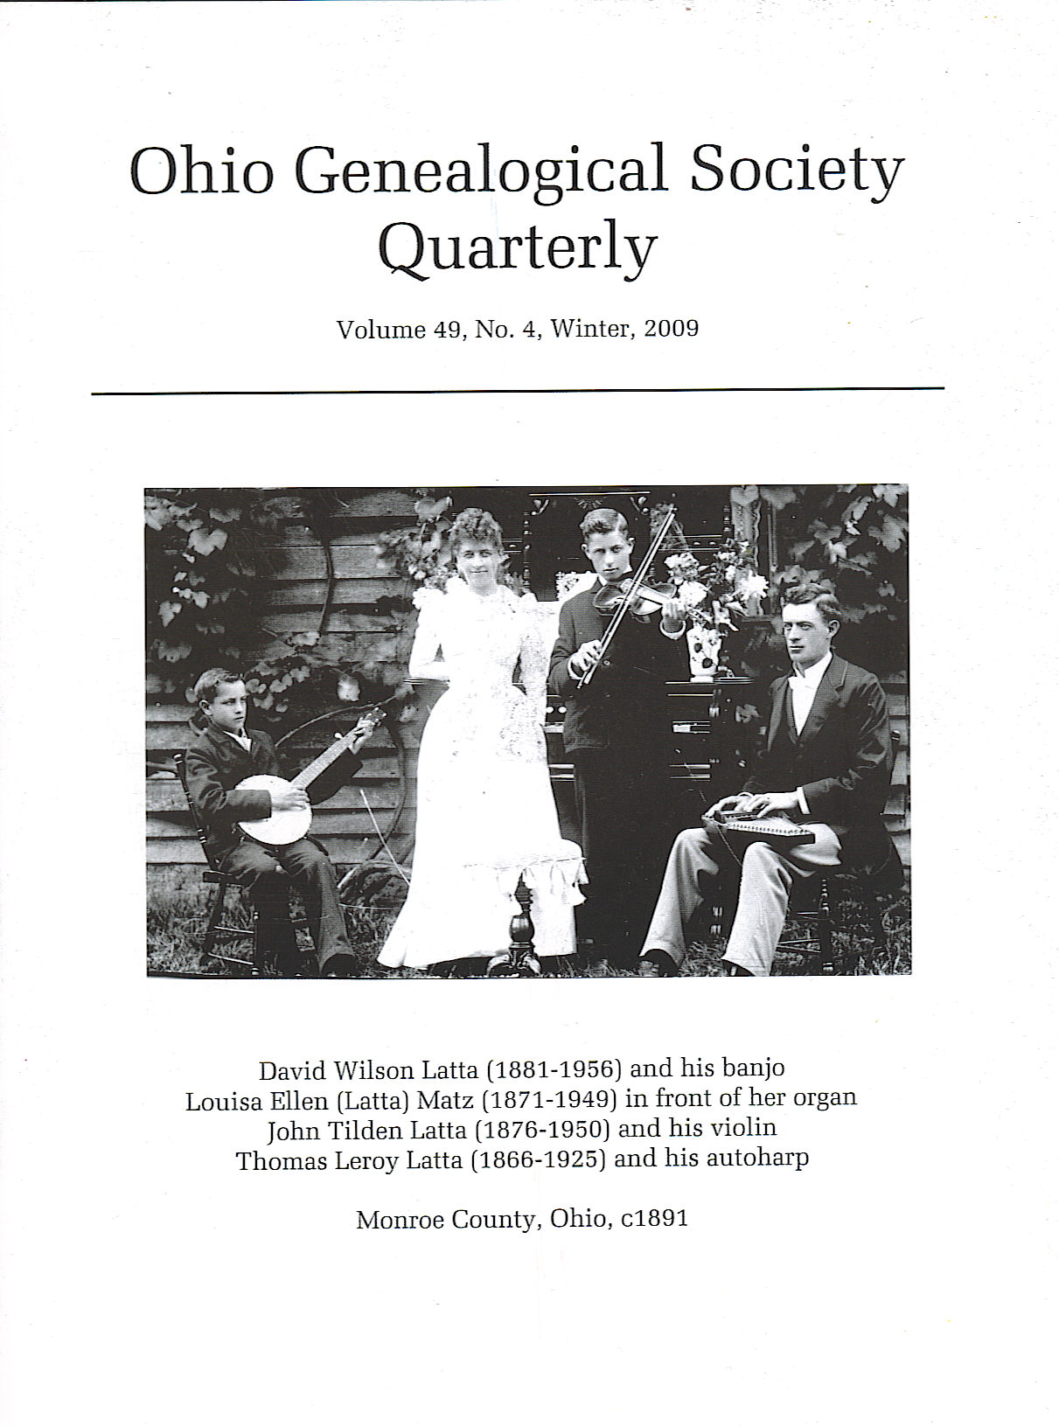

Monroe County, Ohio, c 1891

Cover Story

Life in Them Thar’ Hills

Betty Latta Kitchen

Most of genealogy is centered on names, dates, places--on births, marriages, deaths. Court documents and obituaries give meager glimpses of lives lived, lives lost. However, the featured picture provides more than just a printed page. It “shows” a segment of their lives, of what they enjoyed.
Pictured in this 1891 photo are some of the children of Mary Jane (Morris) and John Copeland Latta. John Copeland Latta was born^{1,2,3,4} on 13 Aug 1837 in Fairmont, West Virginia, the youngest son of Anna Elizabeth (Hockenbury) and John Latta. He died^{5,6} on 10 Nov 1915 in his home near Miltonsburg, Monroe County, Ohio. Mary Jane was the daughter of Mary (Kinkade) and Henry Gusler Morris. She was born^{7,8,9,10,11,12} on 6 Sep 1837 in Woodsfield, Monroe County, Ohio. She died^{11,12} on 13 May 1927 in Malaga Twp., Monroe County, Ohio. The children pictured here are David Wilson Latta (1881-1956)* and his banjo, Louisa Ellen (Latta) Matz (1871-1949)* in front of her organ, John Tilden Latta (1876-1950)* and his violin, and Thomas Leroy Latta (1866-1925)* and his autoharp. I’ve submitted more information and photographs of these extended families to the Monroe County, Ohio web site at http://www.rootsweb.ancestry.com/~ohmccogs/.
The photo was taken outside the home of Mary Jane and John Latta in Malaga Township, Monroe County, Ohio. Monroe County is still referred to as the Little Switzerland of Ohio for its rolling landscape and probably for many of the early settlers who emigrated from Switzerland. The home was built on 62 acres originally purchased by Mary Jane’s father, Henry Gusler Morris, through the Marietta Land Company on 20 March 1837.^{13,14} Mary Jane lived here most of her life. She married John Copeland Latta on 16 March 1861¹⁵ and for a few years lived in Wayne Township with or near John’s parents and his brother Samuel Seymore Latta. Following Henry’s death her husband purchased the property from the other descendants of Henry G. through Quit Claim Deeds, and they lived there the rest of their years. The property is very hilly with many trees. Now the house and the barn are gone. A few shards of pottery, a bottle or two, part of the springhouse foundation are all that remain. Pictures taken around 1940 show a mailbox and a car parked by the house. Now one cannot tell that a road ever existed there. Accessing the cemetery on the property where Henry Gusler Morris, his wife, and several descendants rest takes 50 minutes of struggling through the floribunda and walking on the sides of hills. One leg is always higher than the other. No paths even remain. Even in the life spans of these people working that land was difficult, very difficult. Louisa [pictured in front of the organ] told her niece, Jan Edith Latta, that even the horses had to work hard. Louisa, who really liked to dress up and wear fancy clothes, and her husband Chris Matz moved to Ashland, Ohio to raise their family.
With all that work, what did they do for fun?
Music was important to them. In addition to the picture, we have a yellowed newspaper clipping about the birthday party for another sister, Mary Belle Latta, probably around 1899 that says, "The beginning of the evening was spent in social chat, interspersed with instrumental music by J. T. Latta and sister and brother, after which came the ice cream supper (with cake and lemonade to prevent taking cold.) During supper J. T. Latta gave us some fine comic songs with banjo accompaniment." The article went on to include the names of almost fifty guests and the gifts, that included a black serge dress pattern from her parents, a fancy hair pin from her little brother Davy, a lamp from her sister Lou, a silk handkerchief from her brother J.T., and a water pitcher from her brother Thomas and his wife.
John Tilden Latta, usually referred to as “J.T.,” [pictured with his violin] wrote poetry before the age of twenty. A small copy of his book, School Poems, copyright 1901, was published in Newark, Ohio. He played several stringed instruments. J.T. went to the Doane Academy. The invitation for his commencement on June 10th, 1902, held in the Baptist Church in Granville, Ohio, addressed to his brother David Wilson Latta, is in our collection. He continued his studies at Denison University and the University of Chicago. In l904 his address was 52 M.D. Middle University Hall. A flyer entitled UNION Revival Meetings, Lake Geneva Wisconsin, pictures thirteen young men on its cover with the caption EVANGELISTIC BAND OF THE UNIVERSITY OF CHICAGO. Under “Members of the Band” J.T. Latta is listed as a hymn writer. In addition to his book of school poems his daughter Lois told me that he wrote 300 songs and about 1000 other poems. Lois said that he married Mary Elizabeth Udell on September 9,1905, in Gibson, Ohio, and was ordained at the Salem church in October and then went to Burma as missionaries with the A.B.F.M.S. (American Baptist Foreign Missionary. They arrived in Rangoon December 19, 1905, and proceeded on to Thonze the next day where he served until April 1, 1940. [The family did return home for sabbatical leaves during that time.]
Thomas Leroy Latta [pictured with the autoharp] taught at several schools in the area before becoming county school examiner. Both his brothers Davy and J.T. were his students in 1894. A brown notebook, top-bound with spiral wire, typical of stenographer use, shows his lessons around 1894. It has a section listing the 29 students with tic marks behind their names as to how many of the 46 quotations in the lesson-plan book each student had mastered. They were listed as TREASURED THOUGHTS, and one was:
“I willingly renounce the world, which has to present . . . * that music is a higher revelation than all their wisdoms and philosophy.”–Beethoven [My note: *I cannot read the handwriting at this point.]
Oral recitation was important. Parts of a play written in vernacular style, ending with a line with the single word “Curtain” were included in the book. The addition of the word “Curtain” indicates to me that the students performed the play.
My grandfather, David Wilson Latta, pictured with the banjo, met his future wife Effie Jane Schaub at singing school. As an adult, he loved the opera. He attended the opera and collected many opera records. He also enjoyed photography and had a dark room set up as a teenager. He considered becoming a photographer until a cousin told him, “Give me a nickel’s worth, Dave.”
In addition to music, politics was another interest of my grandfather. He believed strongly in the two-party system, and because of that, he would always insist on voting. He had strong political feelings even as a youth. At least two of his editorials were published in the Saturday Evening Post when he was a teenager still living in "Miltonsburgh," Ohio. Below is one of the editorials:
Editor, Saturday Evening Post:
The able treatment of the editorial, Our New Midway Plaisance,
has caused it to be read with more than passing interest.
It seems to me that there is danger of becoming an Imperial Republic.
If there is not, how can we face expansion? Can we hold out the
Monroe Doctrine, on the one hand, and say to the Powers, Keep Off
the Grass, and on the other deliberately trample upon it ourselves?
No. There is danger of becoming vain because of our achievements.
Look at the tone of our ultimatums to Spain and note the Imperialistic command that is implied.
It seems that almost every man of office who has any influence whatever is trying to climb on some person's shoulders and then push
him down as he springs upward, that he can give Imperialistic commands.
For instance, look at General Miles' military bill. It provides for a Lieutenant-General. Who will that Lieutenant-General be? Look at
the International Bimetalism scheme and see what a snare that
was. The time seems fast approaching when the officials at
Washington will lay off their cloaks and, swaggering round
in their seeming importance, say to other nations, "You shall."
Miltonsburgh, Ohio
D. W. L.
David graduated from Cornell University in Ithaca, New York, in 1903. The family legend has that he got there by riding his bicycle [quite a distance from Monroe County, Ohio] and that he supported himself while in school by working as a beekeeper.
In 1913 David began working with the Kuehn-Wilson Electric company for $3.50 a day, and he worked ten hours every day. In June 1918 he was hired by the Hercules Motors Company in Canton, Ohio. Later he became a designing engineer. He liked to invent. Another yellowed clipping shows:
PATENTS OBTAINED
“Frease & Bishop, patent attorneys, list these patents as granted during the week . . . and Hercules Motors Corp. assignee of David Wilson Latta, patent on governor controlled compression ignition.”
During the depression Hercules had a five-year project with the Russian government. Although David enjoyed golf, by the 1940's he no longer had time to pursue that recreation. During the war years everyone worked for the war effort. Plants worked 24 hours a day, seven days a week, so he was very busy. He traveled throughout Michigan, Illinois, Indiana for the firm. During the week he lived in Chicago and took the train home to Canton, Ohio, on weekends. One of his proudest possessions was an Ordinance Distinguished Service Award, presented to him on July 20, 1944, as a member of the Coordinating Research Council in recognition of "outstanding and meritorious engineering advisory service" to the U.S. armed forces.
David also enjoyed gardening and had a green house as well as a “posey” room.
Sister Mary Belle, not in the musical picture–what did she do for fun? She enjoyed collecting autographs. Her little (2 ½ x 5 inches) velvet album began with this dedication she wrote in 1889.
Go forth thy little volume
I leave thee to thy fate.
To love and friendship truly,
Thy leaves I dedicate.
Mary B. Latta
[It is very interesting for me as I work on genealogy to read through each autograph and be able to recognize who most of the people were.]
Mary Belle lived in the family home and took care of her parents as they aged. She never married. Mary Belle liked to garden. Photographs circa 1938 show beautiful flowers surrounding the house. She was also a very good shot with a rifle. This story was related to me by Frank Christman in 1997. The drama occurred in the late 1930's, early 1940's. Frank and his older brother Vernon had been practicing with their 22's, and now that they were teenagers they figured they were getting pretty darn good. So one day they decided to challenge that old lady who lived up the “holler.” Everyone talked about how good a shot she was. Nobody messed around her place, and folks were afraid to hunt on her property. So Vernon and Frank hiked up the holler to show her a thing or two. Mary Belle said okay, she'd do some shooting with them. Vernon hammered a nail into a tree, and they stepped off 50 paces. Vernon shot first. His shot barely missed the nailhead, a little to the right. Frank's next. His shot was close, but a little to the left. The only one still to shoot was Mary Belle. She took aim and hit that nail right on the head. She went back into her cabin, and the boys hung their heads in shame as they traipsed back down the “ holler.” They couldn’t imagine how could that old lady have beaten them.
Other children in this family not previously mentioned include the first two little boys. An ornate memorial wall hanging gives testimony to their birth and their death. Henry Harvey was born February 13, 1862, and Samuel Seymore II on July 8, 1864. Both little boys died within days of each other–-September 24 and September 26, 1865–from cholera.
The birth of another son, Allen Forrest Latta, varies according to the source. Although his death certificate gives February 15, 1874, he was listed as age 1 in the 1870 census of Monroe County, Ohio. The parchment invitation to his graduation from the Louisville [Kentucky] Medical College on “Friday, March 8th, 1895, at 2 o'clock, Masonic Temple" supports the earlier date. Following graduation Allen Forrest, known in the family as Doc, practiced medicine for many years in Graysville, Monroe County, Ohio.
Life in them thar’ hills? It was hard, so hard. Yet it was the impetus that drove the dedication to education that resulted in the doctor, the teacher-school examiner, the teacher-missionary, and the engineer–The Latta Family.

Notes:
*The Morris-Latta Family Bible, death certificates and obituaries were used for all the dates within the article unless otherwise stated. Monroe County, Ohio birth records and various census records were also used. A complete listing can be provided.
1.obituary, yellowed clipping from the collection of David Wilson Latta
2. death certificate for John Copeland Latta, #62134, Monroe Co., OH.
3. CENSUS, 1910 Malaga Twp., Monroe Co., OH.
4. CENSUS, Wayne Twp., Monroe Co., OH, p 291
5. obituary, yellowed clipping from the collection of David Wilson Latta
6. death certificate, #62134 Malaga Twp., Monroe Co., OH.
7. death certificate, #30855, Monroe Co., OH.
8. BIBLE RECORD. The Henry G. Morris Bible is currently in the possession of this writer.
9. CENSUS, 1910 Malaga Twp., Monroe Co., OH.
10. CENSUS, Wayne Twp., Monroe Co., OH, p 291
11. obituary, yellowed clipping from collection of David Wilson Latta
12. death certificate, #30855, Monroe Co., OH.
13. MORRIS, HENRY G: Land Office: MARIETTA; Document Number 276; Total Acres: 61.76; Date: March 2, 1837
14. 23-page ABSTRACT OF TITLE OF THE LANDS OF MARY BELLE LATTA SITUATED IN MALAGA TOWNSHIP, MONROE COUNTY, O.
15. original marriage license belonging to John C. Latta and Mary Jane Morris

